**Lego Soldering Station**

|  |  |
| --- | --- |
| Author | Loïc Schillings |

Content

1 Introduction 1

2 Material and methods 2

2.1 The case **…………………………………………………………………………………………………………………………………**..2

2.2 The PCB **……………………………………………………………………………………………………………………………………**2

2.2.1 The components **….……………………………………………………………………………………………………………**3

2.3 Design flowchart **………………………………………………………………………………………………………………………**4

3 Results 6

3.1 Temperature selection 6

3.1.1 Electronic level 6

3.1.2 Display 6

3.2 Funtionality 7

3.2.1 User-friendly maintanance 7

3.2.2 PCB 7

4 Discussion 8

5 Reference list 9

# Introduction

My initial undertaking as a student of electronics and ICT at PXL would involve constructing a soldering station. The reason to build a soldering station is because it is always useful for an electronics engineer.

It will appear as a large Lego brick, but with a soldering iron attached to it, also looking like a large Lego brick.

The soldering station has a feature to modify the temperature of the soldering iron to your needs.

To build this soldering station, designing the PCB and soldering the parts onto it, and design the Lego brick inspired case, was done by myself.

The electrical schematic to design the PCB, came out a magazine called “Elektor”. A known source of information and inspiration for electronic engineers. So that is were the project began.

This document will describe the components for the soldering station, the way it is manufactured and the result of the project.

# Material and methods

## The case

The case of the soldering station is made from generic PLA, which is 3D printed into the required shape.

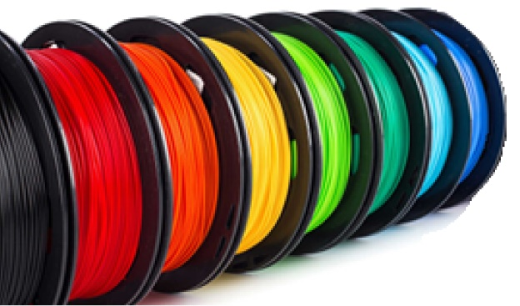 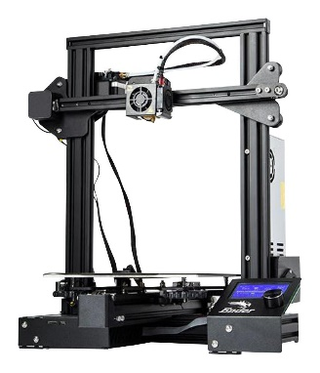

The simplicity lies in the fact that it is both affordable and easily reproducible through printing.

And the biggest advantage of using a 3D printer is the freedom to create a case in any shape or form desired.

The shape of the case is designed in Autodesk Fusion 360. Which is a 3D modeling software to create any shape. It also gives the opportunity to develop machines.

## The PCB

The PCB or printed circuit board is designed using the Altium Designer software.

This is a 3D model of the almost finished PCB in the soldering station.

Altium Designer offers the possibility to design schematics and PCBs.

Using the drawn schematic, the software is able to insert all the components of the schematic, into the PCB.

Only requiring the user to place all the component on the right spot and connecting everything.

### Components

Smaller parts like the brain of the PCB, the ATMEGA4809, and others like resistors and capacitors are SMD.

SMD stands for surface mounted device, meaning that the part is attached on the top layer of the PCB. A SMD part is not visible on the other side of the PCB, unlike THT parts.

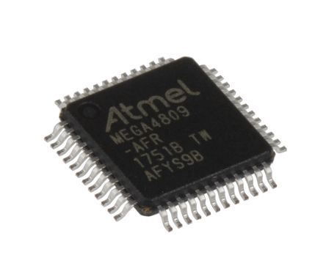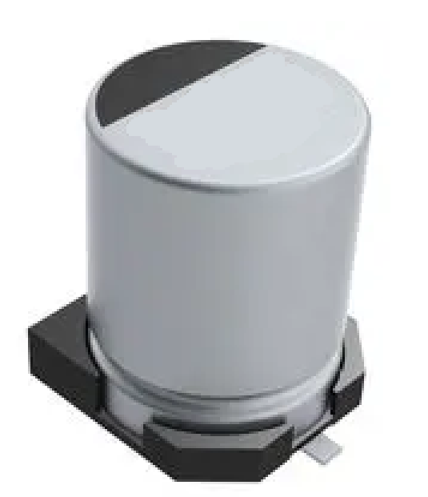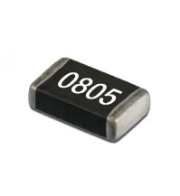

Bigger parts like the display, relay and big capacitors are THT parts. THT stands for True-Hole Technology, those parts mount through a conductive copper hole in the PCB which makes the components leads visible from both side. A lead is a hard wire attached to a component to mount it on the PCB.

On the next page is a flowchart, representing the designing process of a PCB.

## Design flowchart

## 

Step 1 of designing a PCB is finding a schematic of the project. Some websites like Elektormagazine, have electronic schematics of projects the magazine covers.

Step 2, the acquired schematic is devided in smaller schematics, to make it clearer. This also makes it easier to place all the components on the PCB later in the design process.

Step 3, Now make project in the software used to make this PCB, Altium Designer.

Step 4, once a project is made, download the symbols of the components required to make the schematics for the PCB.

Step 5, use the previously devided schematics to put all the components in a schematicdocument, and connect all wires at the right components.

Step 6, after making all the schematics, download the component footprints. Footprints are drawings that represent the real area the component will cover on the PCB. These also show the PCB manufacturer where and what size to put the pad on the PCB to solder components and connect it all.

Step 7, make a blank PCB design. This can be done by right-clicking the project, hovering or left-clicking the tab “Add new to project” and clicking on PCB.

Step 8, generate the different schematics previously drawn into the PCB by going to a schematic, design and updating the PCB document. Afterwards place all the components in the black PCB area, preferably by having as less gray lines crossing as possible. These gray lines represent a wire on the PCB, connecting to terminals or connections form two or more components.

Step 9, route all wires to the right port at the right component. If the schematic is drawn correctly, the gray lines between the components show which port to connects to a port. These wires are placed on the top and bottom of the PCB, two wires on the same layer cant cross because that would short the circuit. Effectively damaging or destroying it permanently.

Step 10, when all wires are routed and all components are connected, press on 3 above the E button, to show a 3D model of your PCB. If all 3D models are downloaded, which isn’t necessary, all components will be visible. If not, only the wires, PCB itself and footprints will be shown.

# Results

## Temperature selection

A knob can be found on the front panel of the soldering station. Rotating the knob clockwise will increase the temperature, rotating counterclockwise will decrease the temperature. The temperature will be shown on the 8 digit display above the knob. Pressing in the knob will confirm the selected temperature and the station will lower or raise the temperature of the soldering iron to the users input.

### Electronic level

When the selected temperature is confirmed, the rotary encoder behind the knob will send a signal through the display PCB, into the flat cable to the main PCB. Where the signal will travel to the CPU, when processed the CPU will send it to the PWM circuit which will adjust the temperature of the soldering iron connected to it.

### Display

|  |  |
| --- | --- |
| Using a 4 Digit & 7 Segment Display, With Arduino : 7 Steps - Instructables | This 4 digit 7 segment display is used to show the temperature of the soldering iron. It could even show comma numbers with its decimal points. |

## Functionality

### User-friendly maintanance

|  |  |
| --- | --- |
|  | An advantageous feature of using magnets to mount all body panels is the elimination of the need for screwdrivers or specialized tools when opening the case.  Another benefit is that even the soldering iron is securely held in the holder using magnets, preventing it from falling off, especially when it is hot.  An additional advantage is the ease of customization, as users can easily replace or interchange panels on the case to achieve their desired aesthetic. |

### PCB

|  |  |
| --- | --- |
|  | I am delighted with the excellent outcome, particularly the visually appealing appearance of the finished PCB. Opting for a black manufacturing color has proven to be a wise decision as it complements the soldered components exceptionally well, resulting in a truly remarkable look.  Despite initial issues, I have successfully resolved all problems with the PCB, making it fully functional. The only remaining task is to address the incorrect wiring of the display, which will be rectified before the presentation. |

The challenges I encountered and the solutions implemented will be elaborated upon in the discussion section of this document.

# Discussion

While designing the PCB, I haven’t had many problems. Except for some issues with the downloaded footprints and symbols. Those problems were easy to solve.

During the initial test of my PCB, the buck converter responsible for generating 5V from the 12V input failed to produce any output. Subsequently, in the second test, the bridge rectifiers were inadvertently soldered in reverse, resulting in their malfunction and subsequent damage. To rectify this issue, I had to carefully desolder the faulty rectifiers and replace them with new ones, ensuring they were soldered in the correct orientation, taking into account the reversed footprint. Following these adjustments, the PCB operated flawlessly, demonstrating full functionality.

It came to my attention that I had mistakenly ordered a common cathode display instead of the required common anode display. Fortunately, when seeking assistance from my classmates, one of them graciously offered to exchange our displays, allowing me to proceed with testing. As a result, I had to rewire the display's connections, although they are not currently wired correctly, I will rectify this situation shortly.

Numerous challenges arose during the printing process for the case. Initially, while attempting to print the required parts, I encountered issues with filament adhesion to the print bed. To address this, manual adjustments to the print bed were necessary while the printer extruded the initial lines of filament.

Subsequently, while printing the penultimate part, I noticed a breakage in the tension arm, responsible for pushing the filament against the extruder gear. I temporarily resolved this setback by employing glue, but unfortunately, the arm broke again during the final print, rendering it useless. Consequently, I had to halt the printer operation.

Upon investigation, I discovered that the Bowden tube, responsible for guiding the filament to the extruder, had become completely clogged, rendering the entire filament feeding system non-functional. As a solution, I procured and installed a new direct drive infeed kit, which not only resolved the problem but also enhanced the printer's capabilities and performance.

# Reference list

Elektor magazine – concept and schematic

<https://www.elektormagazine.nl>

EasyEDA – provider of symbols and footprints

<https://easyeda.com/nl>

Fusion 360 – self-made 3D models

<https://www.autodesk.be/nl/products/fusion-360/overview?term=1-YEAR&tab=subscription>

Mouser Electronics – online shop for components

<https://www.mouser.be>

LCSC Electronics – online shop for components

<https://www.lcsc.com>